PYTHON ESSENTIALS

Project Report
PREPARED FOR :
Dr
r. G.Ganeshan

TO-DO LIST

Introduction
The Project Outcome is the successful delivery of a functional
Python CLI application (todo.py). It fulfills its core objective by enabling users to add, view, and delete session-based tasks via an
interactive menu. The project demonstrates command-line
programming proficiency and includes robust input handling.

Problem Statement
As outlined in the statement.md file, the core problem addressed is the need for a
minimalist, readily accessible task
management tool. Many users require a simple
digital scratchpad for temporary reminders and task tracking without the overhead of
complex, feature-rich software. The lack of an organized system leads to forgotten tasks and
decreased productivity. This project provides a lightweight, session-based solution to mitigate this issue.
Functional Requirements
S. No. | Requirement | Description
1. | Add Task | The user must be able to input a description and add it to the task list.
2. | View Tasks | The system must display all currently stored tasks in a numbered, ordered list.
3. | Delete Task | The user must be able to select a task by  its number/index and remove it from the  list.
4. | Display Menu | The system must continually display an  interactive menu with options (Add, View,  Delete, Exit).
5. | Exit Application | The user must be able to gracefully terminate the application.
Non-functional
Requirements
These requirements specify criteria that can be used to judge the operation of the system:
Usability: The interface must be intuitive and easy to navigate using simple numerical inputs.
Performance: All operations (add, view, delete) must execute instantaneously (sub-second response time).
Maintainability: The code must be well-structured, using clear function definitions and comments to facilitate future modifications.
Reliability: The application must handle invalid inputs
(e.g., non-numeric menu choices, out-of-range task numbers) gracefully using error handling (try-except).

System Architecture
The application uses a Monolithic, Single-Tier Architecture model. All components—the user interface, application
logic, and data storage (in-memory list)—reside and run within a single process on the user's local machine.
Presentation Layer (I/O): Handled by Python's input() and print() functions to interact with the console.
Application Logic Layer: Implemented within the main while True loop and conditional blocks (if/elif/else). Data Layer: Tasks are stored in a simple, global Python list (tasks) in memory.

Design Decisions & Rationale
Decision | Rationale
Python List for  Storage | Simplest data structure for sequential in-  memory storage. Perfect fit for the project's  scope of session-based data.
Procedural Approach | Using global variables and functions (instead  of a Class/OOP) makes the code concise and  easy to follow for a small CLI application.
Numbered  Indexing for Deletion | Displaying tasks with enumerate and  requiring the user to input a  1-  based index  is  highly user-friendly compared to 0-based  indexing or deleting by task name.
try-except Blocks | Crucial for Non-functional Requirement Reliability. Ensures the program doesn't crash when users enter non-numeric input for the menu or task deletion.

Implementation Details
The entire application is contained within a single Python file.
Core Data: tasks = tasks [] initializes the global list.
Menu Logic: The display_menu() function centralizes the menu output for code cleanliness.
Control Flow: A while True loop ensures the program continues to run until the user explicitly selects the 'Exit' option.
Deletion Implementation: The core logic for deletion is:
task_index = int(input(...)) - 1 (converts 1-based user input to 0-based list index).
tasks.pop(task_index) removes the item and returns the removed value for the confirmation message.

Screenshots
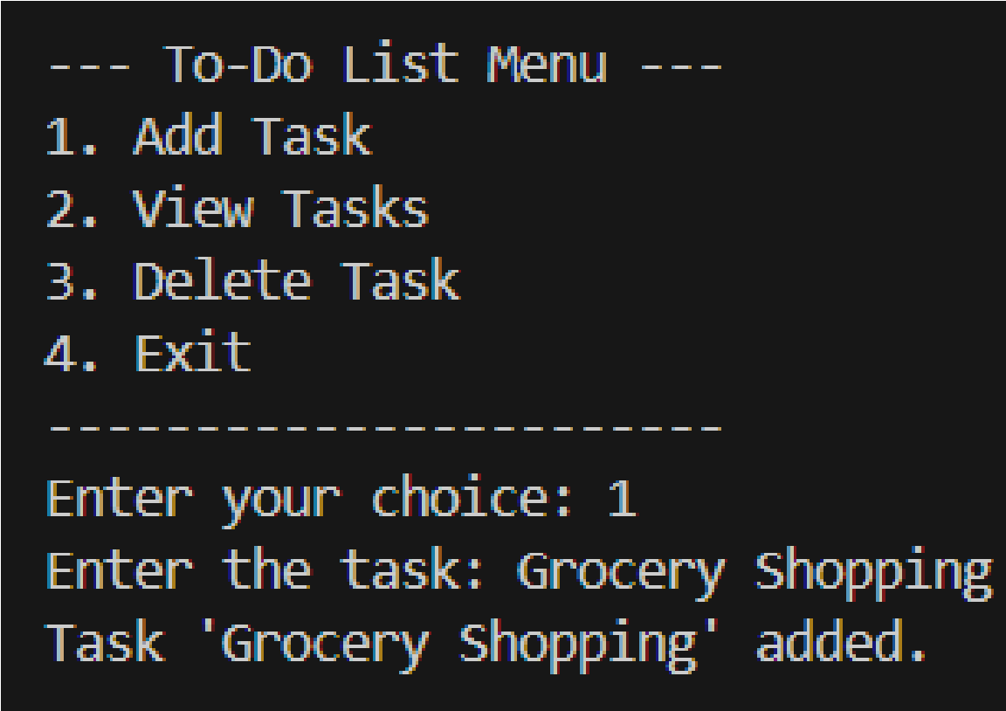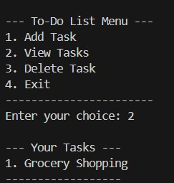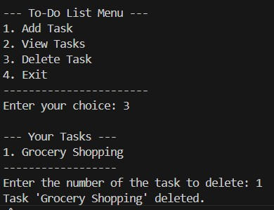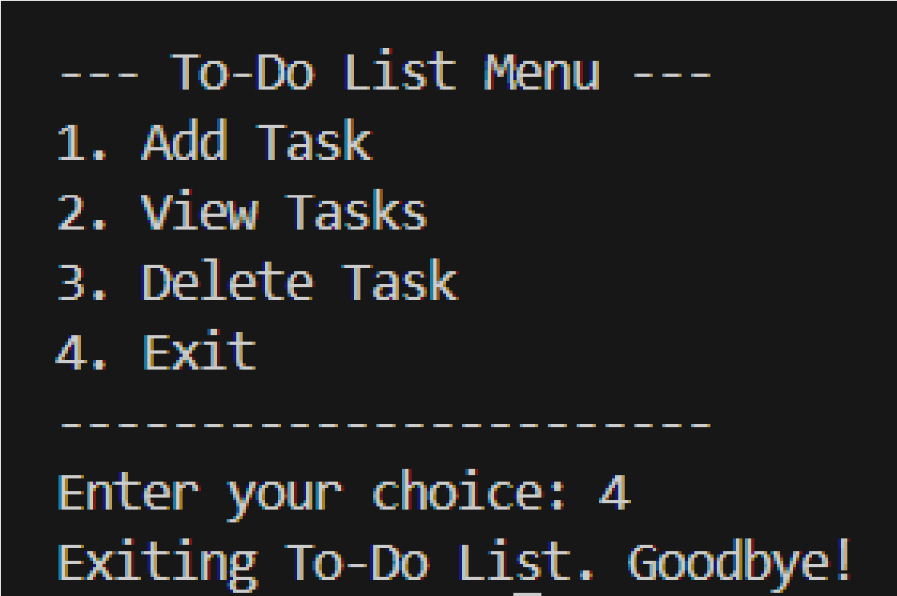
Testing Approach
Test Case | Descriptio n | Input | Expected Output | Statu s
1 | Add &  View Task | 1,  "Groceries ", then 2 | "Groceries" appears as item 1. | Pass
2 | Valid  Deletion | Add two  tasks, then  3  , then  1 | First task is removed; list re-indexes. | Pass
3 | Invalid  Menu  Input | 5 | "Invalid  choice. Please  try again." | Pass
4 | Invalid Delete Index | 3, then 99 | "Invalid task  number." | Pass
5 | Nonnumeric  Delete | 3, then "xyz" | "Invalid input.  Please enter a number." | Pass

Challenges Faced
The most notable challenge was ensuring robust error handling for user input. Index Conversion: Ensuring the conversion from the user's 1-based view to Python's 0based index was correctly implemented and validated.
Exception Handling: Properly implementing the try-except ValueError blocks to catch
non-integer inputs and prevent application
crashes, thereby fulfilling the reliability nonfunctional requirement.
Learnings & Key Takeaways
This project reinforced several key programming concepts:
Loop Control and State Management:
Understanding how the while True loop maintains the application's state
and how to use break for graceful exit.
Data Structures in Action: Practical use of the Python list (tasks) and the
enumerate() function for generating numbered lists.
Defensive Programming: The importance of validating user input
and using try-except blocks to create resilient code.

Future Enhancements
The current project is a minimum viable product (MVP). Potential future enhancements include: Data Persistence: Saving the task list to a file (e.g., CSV or JSON) so tasks persist between sessions.
Task Status: Adding a feature to mark tasks as 'Complete' rather than just deleting them.
Priority Levels: Allowing users to assign priority (High, Medium, Low) to tasks. Refactoring: Converting the procedural code into an Object-Oriented Programming (OOP) structure using a Task class and a ToDoList class.

References
Python 3 Official Documentation – Used for syntax and built-in functions (e.g.,
list.append(), list.pop(), enumerate()).
[Any online tutorials, books, or course materials used to guide the project
structure.]

